NFT trait and price analysis

Bored Ape Yacht Club

Lucas Young | 03/01/2022

# A Brief History of Bored Ape Yacht Club

The Bored Ape Yacht Club NFT (BAYC) is a blockchain-based collection of 10,000 individual art tokens. Released in April of 2021 at an initial price of .08 ETH or about $190.00 at the time, the project has since gone viral. With notable names like Jimmy Fallon, Justin Bieber, Mark Cuban, and Eminem purchasing tokens, and prices reaching as high as $2.9 Million in a matter of months. The project has generated more than $1 Billion in total sales since its initial deployment. The underlying contract, built on the Ethereum Blockchain, also generates a 2.5% commission from all secondary sales for the project’s developers. Each token has a set number of traits that define its image. This includes Background, Clothes, Earring, Eyes, Fur, Hat, and Mouth. Depending on the scarcity of the individual traits and the resulting combination of the traits, an individual token is valued by its rarity within the overall collection.

# What Gives a Bored Ape Yacht Club NFT its Value?

Within the collection of 10,000 tokens that make up the Bored Ape Yacht Club NFT, not all tokens are created equal. The intrinsic value of a BAYC token is based on the individual token’s traits. If the combination of traits that make up a token are common within the collection, that token will have a lower value. If a token has rare traits, its value will be higher. These traits come in the form of visual characteristics displayed on the token. The rarest traits include Cyborg Eye, Cross Earring, and a dagger in the mouth. In the collection of 10,000 tokens, only 49 have a Dagger Mouth trait. These traits give each token an intrinsic value, but can they fully define the value of a Bored Ape NFT?

# Hypothesis: A BAYC Tokens Price is Based on the Rarity of its Combined Traits

To answer the question “What gives a Bored Ape Yacht Club NFT its Value?”, the above hypothesis was chosen as it will require a quantitative measure of the traits of each token, and a clear correlation to the market price of the tokens to be true. The hypothesis provides a clear framework from which we can begin our analysis by defining a relationship between token price and token rarity. If no quantitative relationship can be proven between token price and token rarity, the hypothesis will be disproven.

# Datasets

The primary dataset for this analysis will be the Bored Ape Yacht Club NFT tokens. The 10,00-piece collection will be broken down into individual tokens, and those tokens analyzed for their individual traits. The format for this analysis will be:

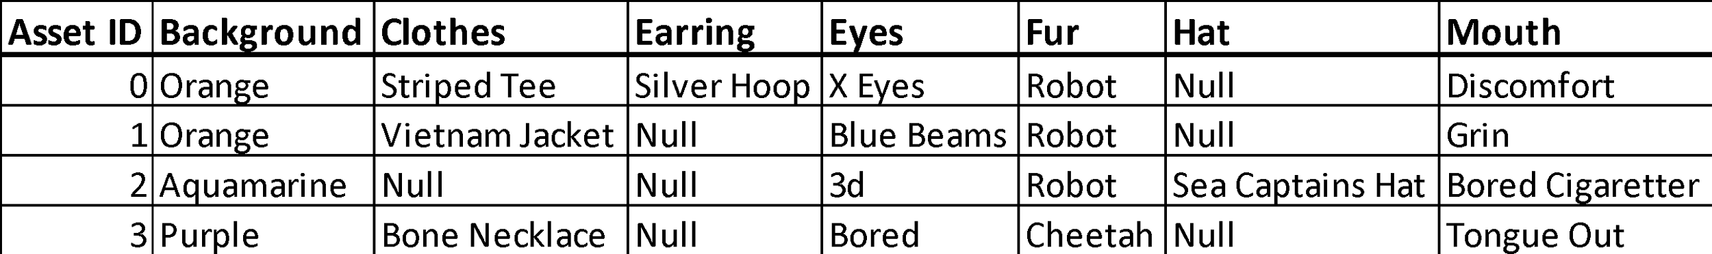

Asset ID is an integer ranging from 0-9,999 and will serve as a key. The seven traits that define each token will be listed in separate columns in the form of strings. As the number of traits varies from token to token, missing traits will have Null values. This data will be accessed by web scraping <https://ape.offbase.org/>. This is a webpage repository of the BAYC tokens and associated traits. This data will then be turned into a CSV file.

The second dataset will be the sales history of the Bored Ape Yacht Club tokens. The total sales history of each token will be included in the dataset, however only the top sales price of each token will be used for the purposes of proving or disproving the hypothesis. Market data will be analyzed and metrics such as trading volume, volatility, and moving averages will be used to provide context to the final analysis. The format of this data is:

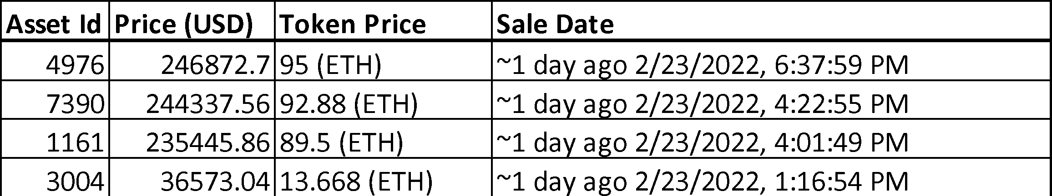

Asset ID is an integer ranging from 0-9,999 and will serve as a key. Price in USD takes the form of a string. Token Price will be parsed into separate columns for the purpose of this analysis, an integer column, and a string column. These two columns will define the token sales price and its sale currency. Sale Date will be reformatted to a timestamp data type to allow for clear analysis of consecutive token trades. This data will be accessed through web scraping <https://nonfungible.com/market/history/boredapeclub>. This is a website that has compiled the entire trading history of the BAYC tokens since the project’s deployment. The scraped data will then be converted to a CSV file.

# Methods

The first step in the analysis process will be defining trait rarity within the total collection. This will be done by calculating each individual trait compared to its appearance within the total population. Once trait rarity is defined, it will be possible to calculate the derived rarity of the individual token. As each token possesses between four and seven traits, the quantity of traits a token has will be considered in the rarity calculation. With each token defined based on its rarity within the total collection, we can compare the sales prices of each token based on its rarity score. The results of the analysis will show either a correlation between price and rarity of the tokens thus proving the hypothesis or show no correlation between price and rarity of the tokens thus disproving the hypothesis.

# Target Audience

The goal of this project is to provide a market analysis of the Bored Ape Yacht Club NFT collection. This analysis can be used by investors and capital allocators who are looking to understand and invest in the Bored Ape Yacht Club collection or NFT markets in general. Hobbyists and individuals who are new to NFTs and the Bored Ape Yacht Club collection will find this analysis informative as a first step into the space of NFTs and Cryptocurrency. Finally, those interested in social trends and viral marketing will be able to use the findings of this study to further their own research and further the development of their projects.